Line Follower Bot

Introduction

This project involves the development of a line follower bot capable of autonomously navigating and following a line on the ground. The bot utilizes various components, including infrared (IR) sensors, motors, motor drivers, an Arduino Nano, and an MPU6050 sensor for PID control.

Problem Statement
In various industrial and educational settings, there is a need for autonomous robotic systems capable of navigating and following predefined paths or lines on the ground. Traditional wheeled robots often struggle with maintaining accurate path tracking, especially in complex environments or when dealing with tight turns or intersections. This limitation hinders their effectiveness in applications such as manufacturing processes, warehousing operations, or educational robotics challenges.
The challenge is to design and develop a line follower bot that can autonomously navigate and follow a line on the ground while maintaining precise path tracking and stability. The bot should be capable of detecting and responding to various line patterns, intersections, and dead-ends, using a combination of sensor inputs and control algorithms.

Components

1. Arduino Nano: The Arduino Nano serves as the primary controller, responsible for processing sensor data, implementing algorithms, and controlling the motors.

2. IR Sensors (3): Three infrared sensors (connected to pins 9, 10, and 11) are used to detect the line on the ground. These sensors are strategically positioned on the bot to enable accurate line detection and tracking.

3. Motor Driver: A motor driver is employed to control the speed and direction of the bot's motors based on the commands received from the Arduino Nano. The motor driver is controlled by the following pins:
- Motor 1: ENA (pin 6), IN1 (pin 2), IN2 (pin 3)
- Motor 2: ENB (pin 5), IN3 (pin 4), IN4 (pin 7)

4. DC Motors (2): Two DC motors are used for propulsion and steering, enabling the bot to move and navigate along the line.

5. MPU6050: The MPU6050 is an inertial measurement unit (IMU) that combines an accelerometer and a gyroscope. It is used for PID control, providing sensor data to adjust the motor speeds and maintain the bot's stability while moving.

6. Chassis: A custom-designed chassis or structure serves as the body of the bot, housing all the components and providing a platform for movement.

7. Power Source: A suitable power source, such as a battery pack, is required to power the bot and its components.

Cost of Components

Part Name | Price | Quantity | Amount
Arduino Nano | 250 | 1 | 250
IR Sensors | 26 | 3 | 78
Motor Driver(L298) | 101 | 1 | 101
DC Motors | 65 | 2 | 130
MPU6050 | 109 | 1 | 109
Wheels | 35 | 2 | 70
Batteries | 100 | 2 | 200
Chassis | 100 | 1 | 100
PCB(blank) | 50 | 1 | 50

Total Cost: 1088/-

Algorithms and Functionality

1. Line Following Algorithm: The bot implements a line-following algorithm based on the left-hand rule. The IR sensors detect the line on the ground, and the Arduino Nano processes the sensor data to determine the bot's position relative to the line. Based on this information, the bot adjusts its movement to stay on the line, turn left, turn right, or turn around at dead-ends or intersections.

2. PID Control: The MPU6050 sensor provides acceleration and gyroscope data to the Arduino Nano. This data is used to implement a Proportional-Integral-Derivative (PID) controller, which adjusts the motor speeds to maintain the bot's stability and prevent tipping over while moving forward.

3. Motor Control: The Arduino Nano sends commands to the motor driver based on the line following algorithm and PID control. The `setMotorSpeeds` function controls the speed and direction of the DC motors, enabling the bot to move and navigate along the line while maintaining its stability.

Circuit and Connections
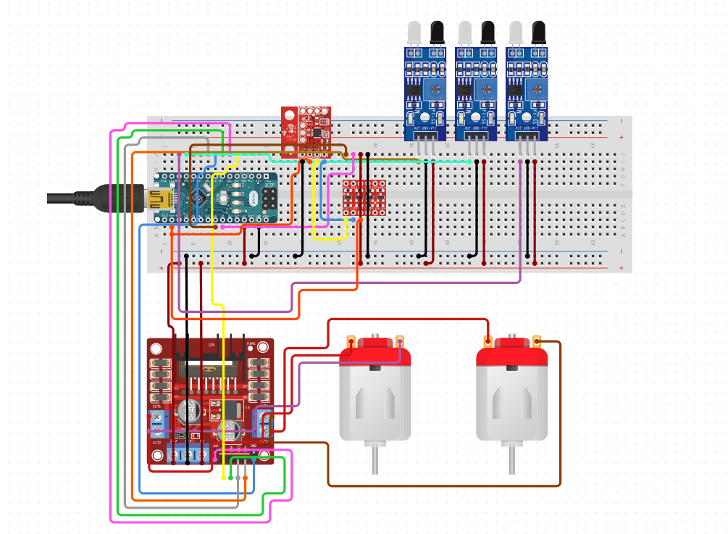

IR Sensor Pins:
- IR Sensor 1: Pin 9
- IR Sensor 2: Pin 10
- IR Sensor 3: Pin 11
Motor 1 Pins:
- ENA (Motor 1 Enable): Pin 6
- IN1 (Motor 1 Input 1): Pin 2
- IN2 (Motor 1 Input 2): Pin 3
Motor 2 Pins:
- ENB (Motor 2 Enable): Pin 5
- IN3 (Motor 2 Input 3): Pin 4
- IN4 (Motor 2 Input 4): Pin 7
MPU6050 Pins:
- SDA (Serial Data): Pin A4
- SCL (Serial Clock): Pin A5

Software Implementation

The software implementation is written in Arduino C++ programming language. The main libraries used are:

- `Wire.h`: For I2C communication with the MPU6050 sensor.
- `MPU6050.h`: A library for interfacing with the MPU6050 sensor.

The code is structured as follows:

1. `setup()` function: Initializes serial communication, sets pin modes, and initializes I2C communication and the MPU6050 sensor.
2. `loop()` function: Reads the IR sensor values and calls the `processIRValues` function to handle line following and navigation.
3. `processIRValues()` function: Implements the line following algorithm based on the left-hand rule. It determines the bot's position relative to the line and calls the appropriate movement functions (`moveForward()`, `turnLeft()`, `turnRight()`, `turnAround()`, `handleIntersection()`).
4. `moveForward()` function: Implements the PID control algorithm using the MPU6050 sensor data. It adjusts the motor speeds to maintain the bot's stability while moving forward.
5. `setMotorSpeeds()` function: Sets the speed and direction of the left and right motors based on the provided parameters.
6. `stop()` function: Stops the bot when the end of the maze is reached.

Future Improvements

The provided code includes additional functions `CALCULATE_SHORTEST_PATH()`, `optimizePath()`, and `REARRANGE()`, which seem to be related to optimizing the bot's path through the maze. These functions could be implemented in the future to enhance the bot's navigation capabilities and find the shortest path through the maze.

Other potential improvements or additional features that could be implemented include:

- Obstacle avoidance: Integrating additional sensors (e.g., ultrasonic or infrared distance sensors) to detect and avoid obstacles while navigating the maze.
- Wireless communication: Implementing wireless communication capabilities (e.g., Bluetooth or WiFi) to control the bot remotely or transmit sensor data and status updates.
- Maze mapping and path visualization: Develop algorithms to map the maze as the bot navigates through it and visualize the explored paths on a display or computer interface.
- Adaptive line following: Implementing algorithms to adapt to different line patterns or colors, improving the bot's versatility in various environments.
- Power management: Optimizing power consumption and implementing strategies for efficient battery usage or charging mechanisms.

Conclusion
The line follower bot with PID control demonstrates the integration of various components and algorithms to achieve autonomous line following and stability. This project showcases the principles of robotics, control systems, and programming, and serves as a foundation for further exploration and development in the field of mobile robotics.

